**STEPS TO RUN SCRIPT**

**Open Terminal or Command Prompt:** Open a terminal or command prompt on your computer.

**Navigate to the Script's Directory:** Use the cd command to navigate to the directory where your script is saved.

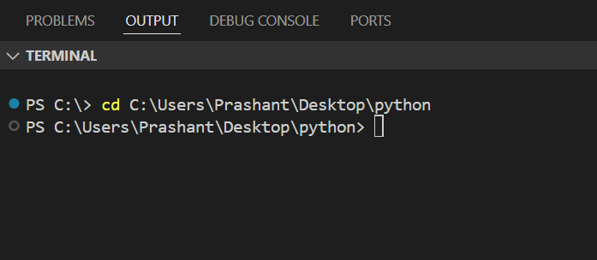

**Run the Script:** Run the script using the python command followed by the script's filename.

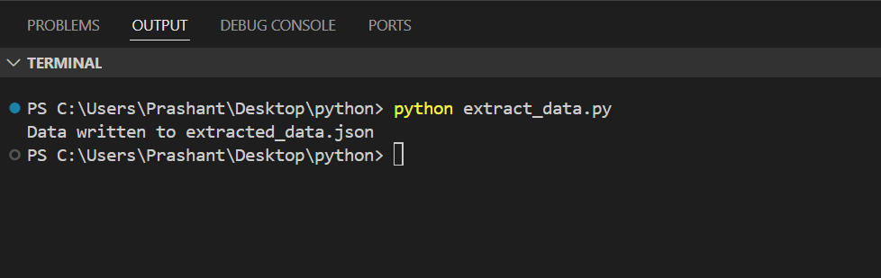

**Check Output:** Wait the script to run completely will take time due to large amount of data, and if there are no errors, it will create a file named **extracted_data.json** in the same directory, containing the extracted data.

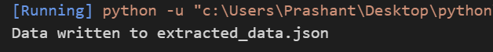

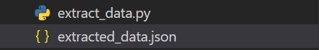

**Note: Make sure you have Python installed on your computer and the necessary packages (requests, beautifulsoup4) installed as mentioned earlier.**